
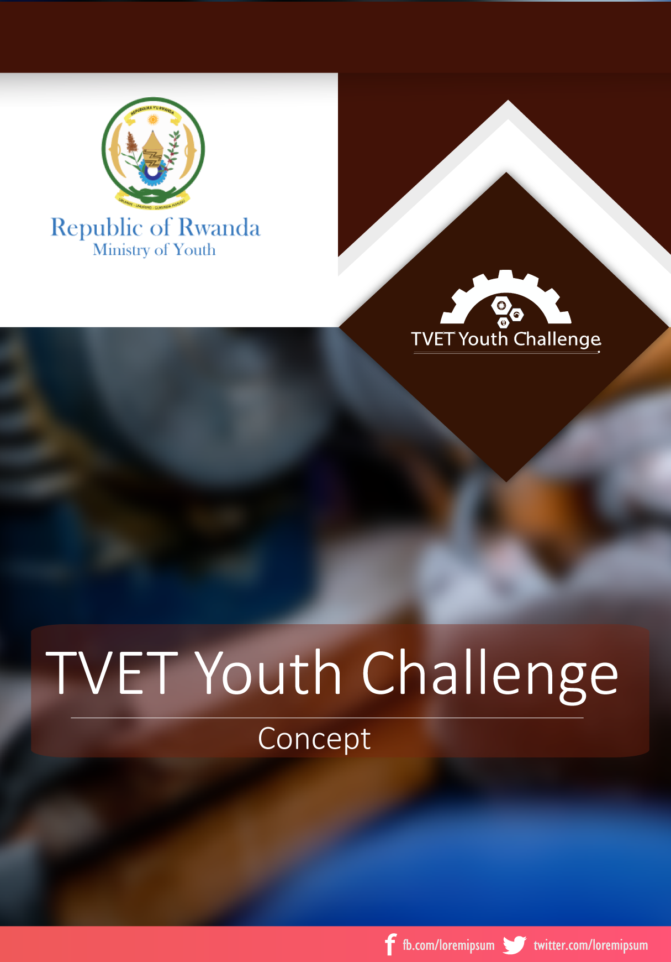


Application Form

- Background
The Government of Rwanda aspires to reach the upper middle-income status by 2035 that will require intense improvements in both the amount and the quality of human capital. Youth empowerment is one of the fastest approach to ensure a sustainable and qualified human capital.

The Government of Rwanda has reinforced its education system by establishing TVET schools to develop practical knowledge based curriculums to create solution makers for community challenges and an upskilled workforce for the private sector.

The TVET Youth Challenge is introduced to support the match between students’ practical knowledge with on ground challenges. Set as a competition, the TVET challenge will be conducted in all higher learning TVET schools, selecting best and innovative applicable projects that are at least on prototype phase.

- Eligibility

- Being Rwandan with 16-30 yrs. old;
- Enrolled under a recognized TVET higher learning school in Rwanda;
- Having a running project or have a proven feasible prototype that is embedded with technologies that modernize agriculture, health, trade, tourism, governance, and business or service systems among others;
- Having demonstrated entrepreneurship eagerness and commitment to develop presented project beyond the education system;

- Application

  - Applicant Information

- Names :…………………………………………………………………………………………………………………………
- ID Number: ………………………………………………………………………………………………………………….
- Gender: Female Male
- Phone Number: ……………………………………………………………………………………………….............
- Email: …………………………………………………………………………………………………………………………..
- School Name: ……………………………………………………………………………………………………...........
- Level: ....………………………………………………………………………………………………………………………
- Faculty /Department:………………………………………………………………………………………………....
  - Project Information

- Name of the project: ……………………………………………………………………………………………………………………………………………………………………………………………………………………………………………………………….
- Field Category:
  - Modernize agriculture
  - Health Solution
  - Trade and Tourism Facility
  - Business and Service system
  - Environmental protection tool
  - Other, please specify:………………………………………………………………………………….

- Stage of the project:
  - Conceptual
  - Prototype
  - Running Project
- Finalized
- Commercialized

- Is the project developed by a team?
- No Yes

If Yes:
- How many team members ..................................................................
- What is the role of each member ………………………………………………………………………………………………………………………………………………………………………………………………………………………………………..
- What is the projection of the project regarding the team composition and agreement?
- Company by shares Cooperative

- Name and Phone number of one of the Members:
…………………………………………......................………………………………………………….
……………………………………………………………………………………………………………………
If No: Kindly Proceed
- Problem statement:

- Proposed solution

- Technical Functionality of the solution

- Customer proven Comments (if any)

- ………………………………………………………………………………………………………………………
- ………………………………………………………………………………………………………………………
- ………………………………………………………………………………………………………………………
- ………………………………………………………………………………………………………………………
- ……………………………………………………………………………………………………………………...

- Expected support if you are selected

- ………………………………………………………………………………………………………………………
- ………………………………………………………………………………………………………………………
- ………………………………………………………………………………………………………………………
- ……………………………………………………………………………………………………………………...
- ………………………………………………………………………………………………………………………

Thank You!

